**TECHNICAL REPORT ON STUDENT INDUSTRIAL WORK EXPERIENCE SCHEME (SIWES)**

**AT**

**SANRAHZ GLOBAL LINK LIMITED,**

**YOLA, ADAMAWA STATE**

**FROM: 4TH JANUARY, 2023**

**TO: 4TH MAY, 2023**

**BY**

**BALA BABANGIDA**

**(SE/ARC/ND/21/024)**

**SUBMITTED TO THE DEPARTMENT OF ARCHITECTURAL TECHNOLOGY, FEDERAL POLYTECHNIC MUBI, IN PARTIAL FULFILLMENT OF THE REQUIREMENT FOR THE AWARD OF NATIONAL DIPLOMA (ND) IN ARCHITECTURAL TECHNOLOGY**

**JUNE, 2023**

**DECLARATION**

This is to declare that I, **BALA BABANGIDA** with registration number **SE/ARC/ND/21/024** undertook my four months SIWES at **SANRAHZ GLOBAL LINK LIMITED, YOLA, ADAMAWA STATE** and have acquired all the experience compiled in this report in the course of my SIWES.

……………………………….. ……………………………

BALA BABANGIDA Sign/Date

**CERTIFICATION**

This is to certify that this report compiled by **BALA BABANGIDA** (**SE/ARC/ND/21/024**) meets the regulations of governing the award of National Diploma (ND) of the Federal Polytechnic Mubi, and is approved by:

………………………………. …………………………

Name of Supervisor Date

**Departmental Supervisor**

………………………………. …………………………

Arc. Dangana T. Halla Date

**Departmental SIWES Coordinator**

…………………………………. …………………………

Arc. Hussaini Haruna Date

**Head of Department**

**DEDICATION**

I dedicate this technical report to God Almighty and to my beloved parents for their support, prayers and financial assistance in all situations especially, Alhaji Babangida Somai Sonka, and Hajiya Amina Banbangida Somai Sonka.

**ACKNOWLEDGEMENTS**

I wish to appreciate God Almighty who gave me the ability, strength and wisdom to study Architecture in Federal Polytechnic, Mubi.

I also, thank my supervisor for his guidance and correction given to me during the period of this attachment and the entire staff of the Department of Architectural Technology, Federal Polytechnic, Mubi.

And also, appreciate my industrial base supervisor and the staff of the Department of Architectural Technology, for the knowledge that they have impacted on me, may Almighty God reward them and bless their effort.

My sincere gratitude also goes to my parents, my beloved brothers and sisters for their supports morally and financially who were always there for me.

**TABLE OF CONTENTS**

TITLE PAGE………………………………………………………………… i

DECLARATION…………………………………………………………….. ii

CERTIFICATION………………………………...………….………………. iii

DEDICATION………….………………………..………….……………….. iv

ACKNOWLEDGEMENT……………………………………….……………v

TABLE OF CONTENTS…………………………………..…….……………vi

ABSTRACT……………………………………………………….…………. viii

**CHAPTER ONE**

1.0 Introduction……………………………………………………………….1

1.1 Aims and Objectives of SIWES………………………………………….. 1

1.2 Brief history of SIWES……………………………………………………2

1.3 Significance of SIWES………………………………………..…..……… 3

**CHAPTER TWO**

* 1. Brief History of Organization………………………..……........................4

2.2 Organogram……..………………………………………..……................. 5

**CHAPTER THREE**

3.0 Description of work experience……..………………………………….6

3.1 Site clearing……..………………………………………..……............. 6

3.2 Setting out……..………………………………………..……............... 7

3.3 Excavation on foundation……..………………………………………..7

3.4 Painting……..………………………………………..……................... 9

3.5 Architectural designs……..…………………………………………… 11

**CHAPTER FOUR**

4.0 Summary, Recommendation and Conclusion…………………………. 15

## 4.1 Problems observed during my program……………………………….. 15

4.2 Summary……..…………………………………………………………15

4.3 Conclusion……..……………………………………………………….16

4.4 Recommendations……..………………………………………………. 16

Reference. ………………………………………..……................................... 17

**ABSTRACT**

*The report summarises the result of work done during my SIWES experience, the technical report consists of four chapters, which comprises of introduction, history and criteria’s of SIWES in chapter one followed by their aims and objectives, historical background, organizational structure of the organization in chapter two, while chapter three consist of the work actually carried out during the SIWES programme and lastly chapter four consist of the summary, conclusions and recommendation.*

**CHAPTER ONE**

**1.0 INTRODUCTION**

The acronym (SIWES) meaning “Student Industrial Work Experience Scheme” is a skill training designed to expose and prepare student in institution of higher for industrial working situation they may likely meet after graduation. The scheme is meant to train student on the method of work and the experience needed in handling the equipment and machines may not to be available in their institution. The scheme is financed by the Federal Government and operators through Industrial Training Fund (ITF), Ogwo, (2001) and operates with National University Commission (NUC), National Board of Technical Education (NABTEC), and National Commission for College of Education (NCCE) and industries. However, SIWES also expose the student to many practical works which the institution did not treat in details without plastering what the institution taught theoretically into practical. A point from academic obtained. SIWES assist the student to understand the nature of his/her work in future.

## 1.1 Aim and objective of SIWES

ITF initiates SIWES with the sole aim of: Exposing student with the practical experience related to the theoretical knowledge acquired in school. Bridging the gap between theoretical learning and practical work situation.

1. To make industries/organization to have confidence in the abilities and capacities of the graduates. SIWES helps the industries to evaluate the prospective employees and give feedback to the institution.
2. It helps the student to gain work and also have experience and confidence as a result if successful completion of a given job assigned to them.
3. To enlist and strengthen the employers’ involvement in the institution activities and in the entire educational process of preparing the student for meaningful and productive employment into industries.
4. It provides an avenue for student in the Nigerian University and Polytechnics to acquire industrial skill and experience in their course of study.
5. Development for greater understanding in other people and proffers skills in human relations.

## 1.2 Brief history of SIWES and ITF in Nigeria

It was said by Dr. Azikiwe Nnamdi, the one president of Nigeria that the practice of work but they all have the same goal that they all want to achieve in countries like china. They established within the premises of institution to provide real life situation, lack of practical skill of locally trained engineers and technologies. the chine way and condition of SIWES is that all institution must give student real life working experience in industrial works. Lecturers are involved in the industrial activities rendering constant services. So, all these countries have their own way of conducting the scheme but all lye on the same goal. And in Nigeria, the history of SIWES can be traced by the history of IITF which is the backbone of SIWES. ITF was established in 1974 under degree of 47 of 1971. It was a body established by the Federal Government of Nigeria and was given responsibility of training indigenous Nigerians. The establishment of the body became necessary due to high demand of Nigeria to take up the vacant positions created in various sector of the economy after the colonial masters have departed. Therefore, the Federal Government discovered that it is easier to train students that are skilled in school to be trained and meet up with gaps in the Nigerian economy and a scheme was established to care for such training and it was named Student Industrial Work Experience Scheme (SIWES). In 1973, the national board of technical education (NBTE) made it compulsory for all the polytechnic students, be it federal or state.

## 1.3 Significance of SIWES to students

Principles taught in the classroom are vein forced given concrete applications on the industrial assignment and students is able to see the relevance of their students which increase their motivation. It helps in given students the knowledge on the types of work to do after his/her graduation. SIWES given students opportunity for a change of environment as they move their institution to the place of attachment which changes the routine types of environment to a word of work. It helps in connecting the institution and the industrial their relationship the introduction of SIWES.

**CHAPTER TWO**

**2.1 BRIEF HISTORY OF SANRAHZ GLOBAL LINK LIMITED**

**MAIN BRANCH**

No.160 Nassarawo Borehole, Jimeta, Yola, Adamawa State

**DATE OF ESTABLISHMENT**

Sanrahz Global Link Limited is a non-governmental organization established at No.160 Nassarawo Borehole, Jimeta, Yola, Adamawa State on 24th August, 2011. It bore the name Salrahz Global Link Limited by the cooperate Affairs Commission. It was a small organization which focused main on designing, construction, making bricks to meet up with construction demands. A new branch was opened at Sakh Plaza, upper floor, No. B1 New NTA Road, Jalingo, Taraba State. This branch is based on construction team that comprises of formidable assembly of experience Architects and Engineers. Aside from the building team they have a technological aspect that focus on manufacturing at the present production. They also engage in manual and electronic drafting for varieties of clients.

**2.2 ORGANIZATIONAL CHART**

**PROJECT MANAGER**

**ARCHITECT**

**CIVIL**

**ENGINEERING**

**ELECTRICAL/MECHANICAL ENGINEERING**

**HEALTH CARE**

**SECRETARY**

**SITE ENGINEER**

**PARK**

**SITE SUPERVISOR**

**LABOURERS**

**FORMEN/ARTISAN**

Figure 2.1: Organizational Chart

**CHAPTER THREE**

**3.0 DESCRIPTION OF WORK EXPERIENCE**

**3.1 SITE CLEARING**

1. Cutting down of trees
2. The unwanted soil was removed
3. All unwanted stones were removed
4. The site was ensured save before work commenced.

**3.2 SETTING OUT**

Square method was used for the setting out, as observed after 90 from all angles using the pages ropes string and also from the plan.

Setting out is done with high degree of accuracy or else the building will not last as the engineer answered to my question “why are some calculations made during setting out”.

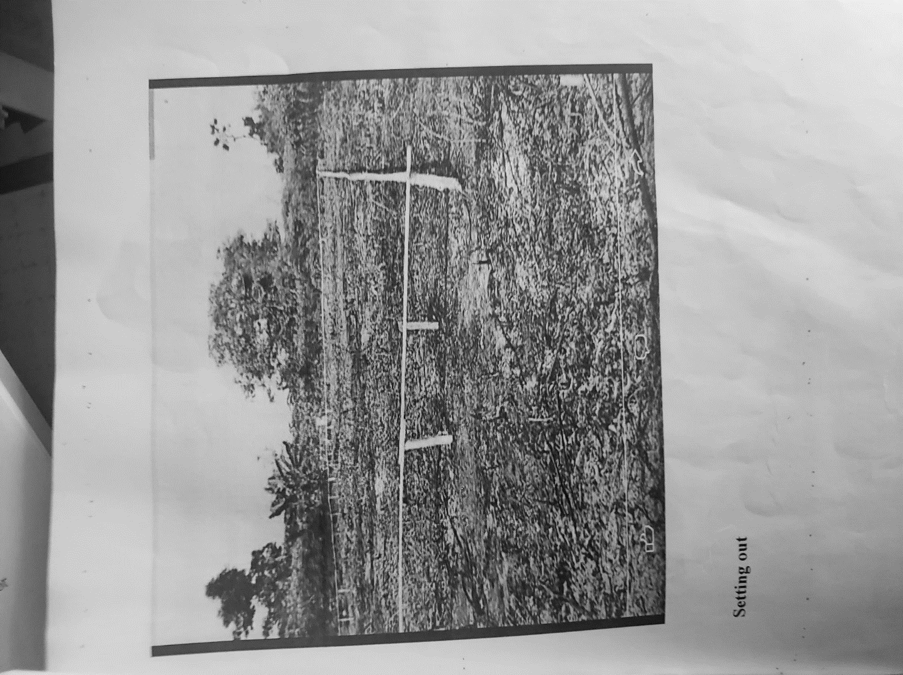

Plate 3.1: Setting out using profile board

Source: Author’s work, 2023

**3.3 EXCAVATION OF FOUNDATION TRENCH AND COLUMN BASE**

Excavation can be defined as the process of digging a soil surface or trench for foundation lay into trench.

It is also the process of removing top soil for foundation trenches. Excavation work is an important part of building operation that commences immediately after setting out the width of excavation for foundation trenches is marked out on the profile and then transferred to the ground. Excavation must be carried out carefully to ensure safety of workers.

Excavation can be done using two methods mechanical and manual. In small construction we normally use manual method while in large construction we use mechanical e.g. like road construction.

Excavation work were carried out manually where unskilled labourer where involved with digger, shovels, head pan and wheel barrow. The following factors must be considered when carrying out any excavation work.

1. Nature of the soil
2. The width and depth of foundation
3. Climatic condition at the time of excavation
4. The water table of the soil
5. The period excavation work is expected to be left open.
6. The effect of excavation on existing adjacent structure.

As the engineer and the former goes to set basket, I was keeping an eye on how the beams were set. When digging the basket some places were 1.2 while some other places were 1.4 by 1.4 because of the type of soil on the site. When putting the basket in a poor soil, cement and sharp sand is mixed out before putting the basket to avoid rusting.

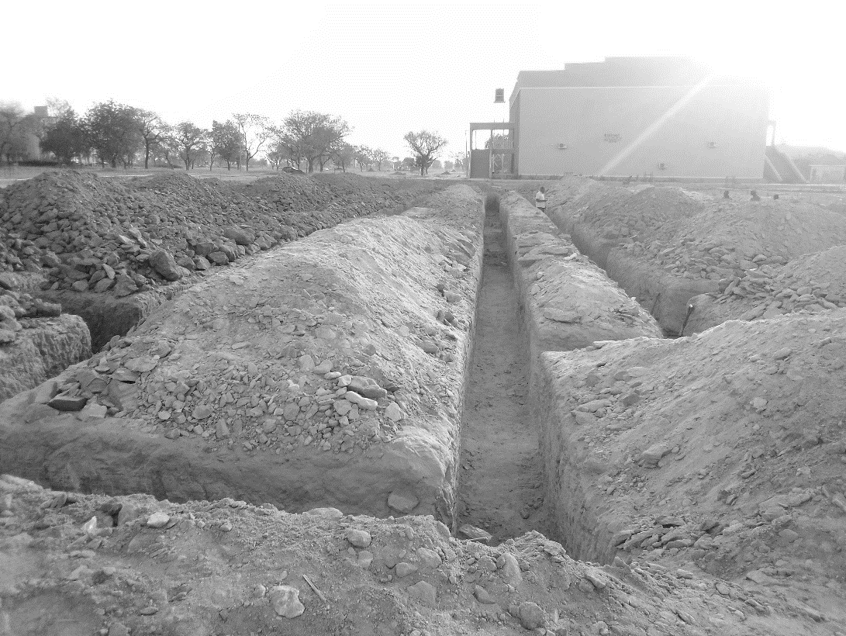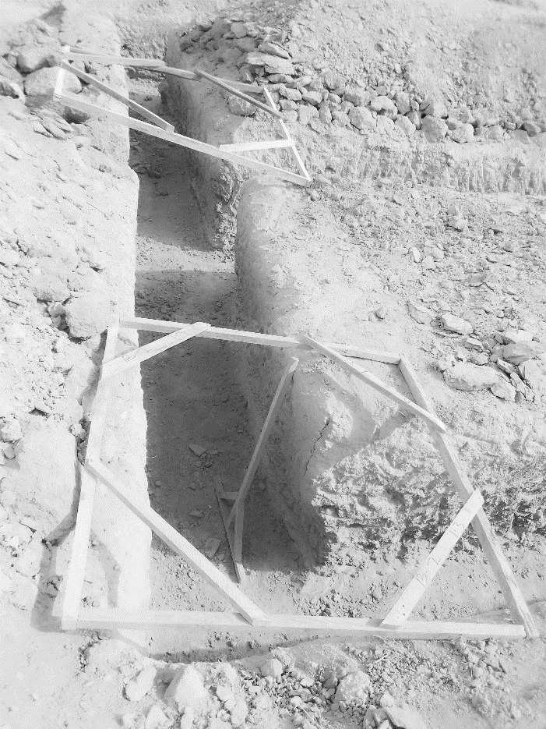

Plate 3.2: Excavation

Source: Author’s work, 2023

**3.4 PAINTING**

To paint a building, several procedures were followed. Here are the steps that were typically undertaken in the past tense:

**Planning and Preparation:**

1. The building's exterior was thoroughly inspected to identify any areas that required repairs, such as cracks, peeling paint, or rotting wood.
2. The necessary materials were gathered, including paint, brushes, rollers, drop cloths, ladders, and any tools needed for repairs.
3. The surrounding areas, such as windows, doors, and fixtures, were covered with protective sheets or tape to prevent accidental paint splatters.

**Surface Preparation:**

1. Loose or peeling paint was scraped off using a scraper, and any rough surfaces were sanded to create a smooth canvas for the new paint.
2. Damaged areas were repaired by filling cracks or holes with appropriate materials, such as putty or caulk, and allowing them to dry before sanding.

**Priming:**

1. A primer coat was applied to the entire building surface to ensure good paint adhesion and uniform coverage.
2. The primer was allowed to dry completely as per the manufacturer's instructions.

**Painting:**

1. The chosen paint color was mixed thoroughly to ensure consistency.
2. Starting from the top of the building, the paint was applied using brushes, rollers, or sprayers, depending on the size and accessibility of the surface.
3. Care was taken to apply an even layer of paint, avoiding drips and streaks.
4. Multiple coats were applied, allowing sufficient drying time between each coat, as recommended by the paint manufacturer.

**Clean-up**

1. Paint spills or drips on unintended surfaces were cleaned immediately using appropriate cleaning agents or solvents.
2. Brushes, rollers, and other painting equipment were cleaned thoroughly with soap and water or specific cleaning solutions, depending on the paint type used.
3. Drop cloths and protective coverings were removed, and the area around the building was tidied up.

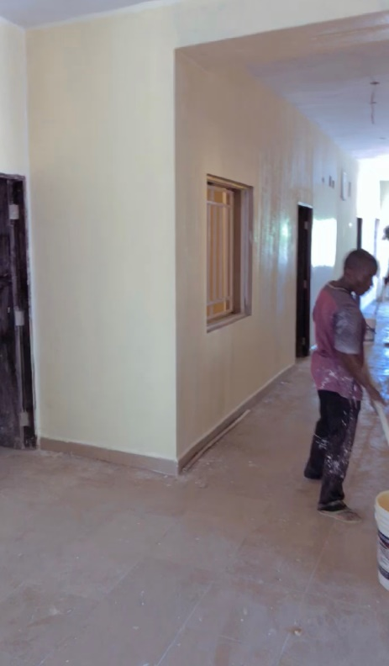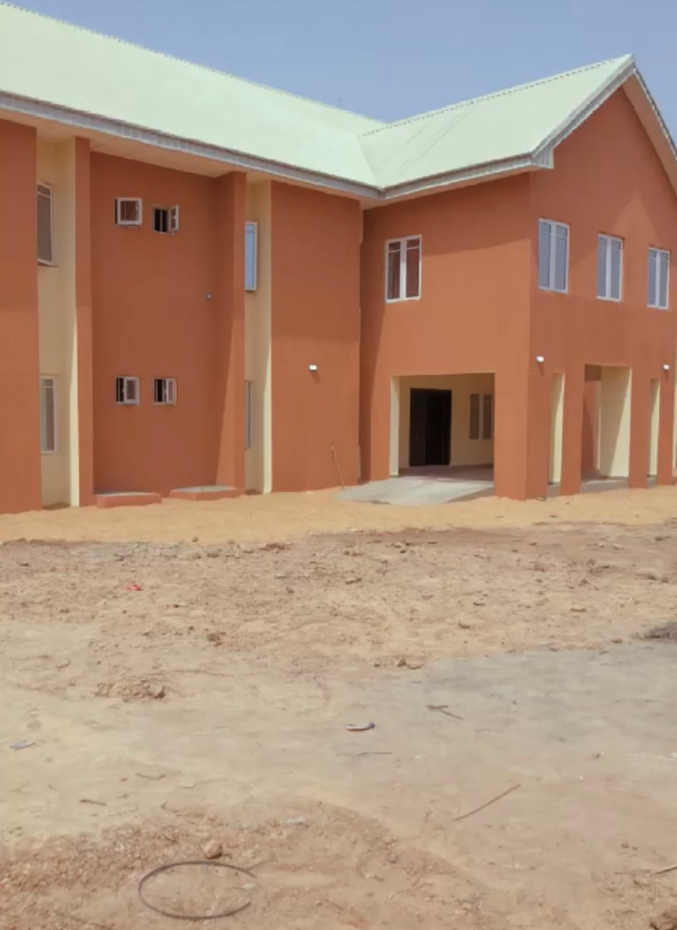

Plate 3.3: Painting of wall

Source: Author’s work, 2023

**3.5 WORKING DRAWING ON SITE**

During my SIWES, I was able to design a floor plan, roof plan, front elevation, back elevation right elevation, and left elevation. Fine attached.

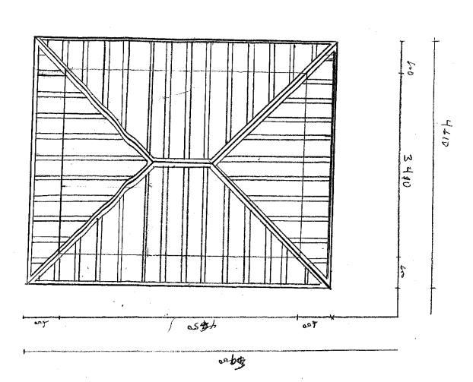

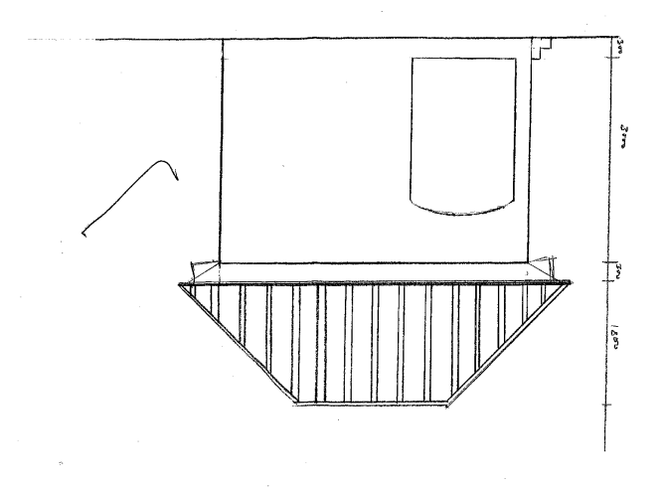

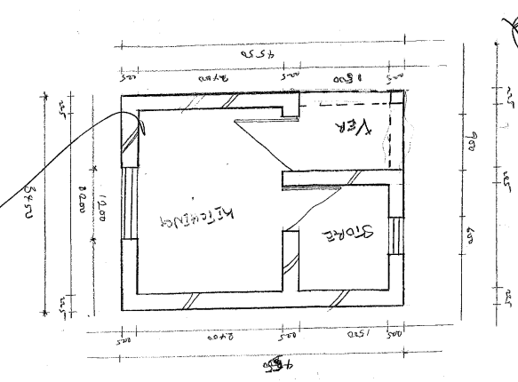

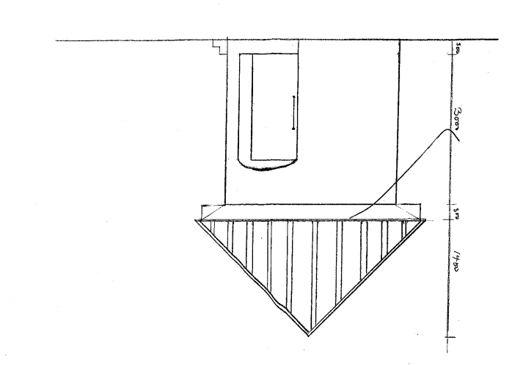

**CHAPTER FOUR**

**4.0 SUMMARY, RECOMMENDATION AND CONCLUTION**

## 4.1 PROBLEMS OBSERVED DURING MY PROGRAM

1. The time frame set for the program is too short as some of the aspects of the program where not completed.
2. Lack of Financial support from the company to aid transportation to and from training.
3. Attentions are not given to the IT students by the workers it is learn if you want to learn or ask if you want to know.

**4.2 SUMMARY**

One would state that the discipline is the training of the mind and body towards effective performance. The Students Industrial Work Experience Scheme (SIWES) is more or less achieving this fit. As it further builds on the theoretical classrooms leaving a practical approach of the industry and commerce to supply of finished goods and services. This program has enabled the participating students to be practically involved in the day-by-day activities of the industries and commerce.

Emphasis in the observation of industrial safety rules and regulations, time critical operation and proper man-hand management, quality cortices, etc. are daily activity objective. All those aimed at the production of marketable goods and services in the world of work.

However, to consolidate on the gains of this Industrial Training Fund (ITF) higher institution coordinator on SIWES program should be allowed making some suggestion and recommendation.

**4.3 CONCLUSION**

SIWES programme is very vital student especially undergraduates, because I come to see the SIWES programme provide an application of the theoretical knowledge learned by student in school to practical or real work situation. Also it is a medium where student from different higher institutions and department come together sharing idea there, by promoting an avenue for learning and them work.

**4.4 RECOMMENDATIONS**

Having being exposed to a bit of what entail working in an individual related to my course of study under SIWES programme I wish to make this recommendation

1. Higher instruction of learning especially either institution and universities should establish link with comprise and establishment so as to provide space for student on industrial attachment, with the option of gaining employment in future, by doing so, it will go a long way in alleviating suffering and difficulties encountered by student in securing place for individual attachment.
2. Student should put money as the primary aim of going SIWES programme, there is more to learn than Bain allowance.

**REFERENCE**

Chudley, R. (2005). *Construction technology* volume 2. Pearson Prentice Hall, New York.

Edward, B. (2003). *The Effect of SIWES on a student*, Federal Ministry of Works, Lagos. Nigeria.

Francis, K. (2012). *Building Construction Illustration*. (Fourth Edition). Wiley Publisher. ISBN-10: ‎ 9788126535637.

Obande, M. (1990). *Blocklaying and Concreting*, 2nd Edition. Pearson Education Limited, Harlow United Kingdom. ISBN13 9780582025417.